Administrator User Manual
Step to Step Guide on how to use this web-based system
- Visit www.hobbsofreading.com. The user is displayed with the main home webpage.
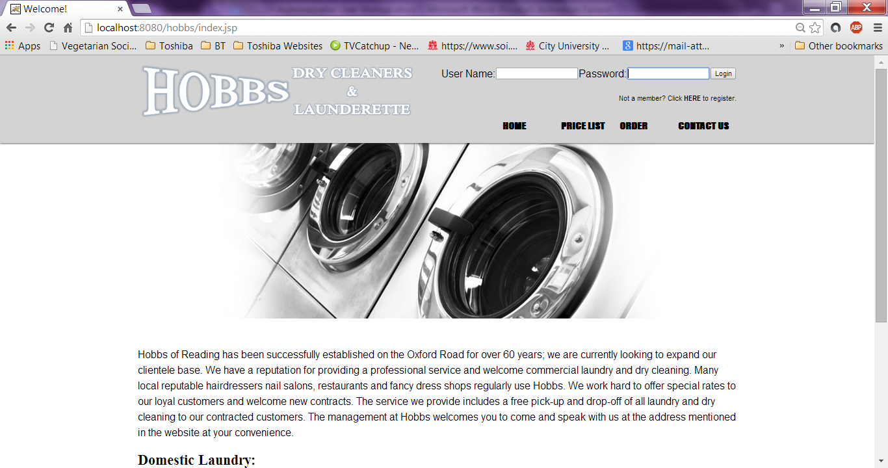
- You need valid administrator credentials to view Admin Panel. Go to the top right corner and enter your username and password. Click Login. Eg. U: Admin, P: admin

Please note: All employees at Hobbs are provided with a username and password. (If you haven’t received this yet, please talk to a registered Admin member to create your account)
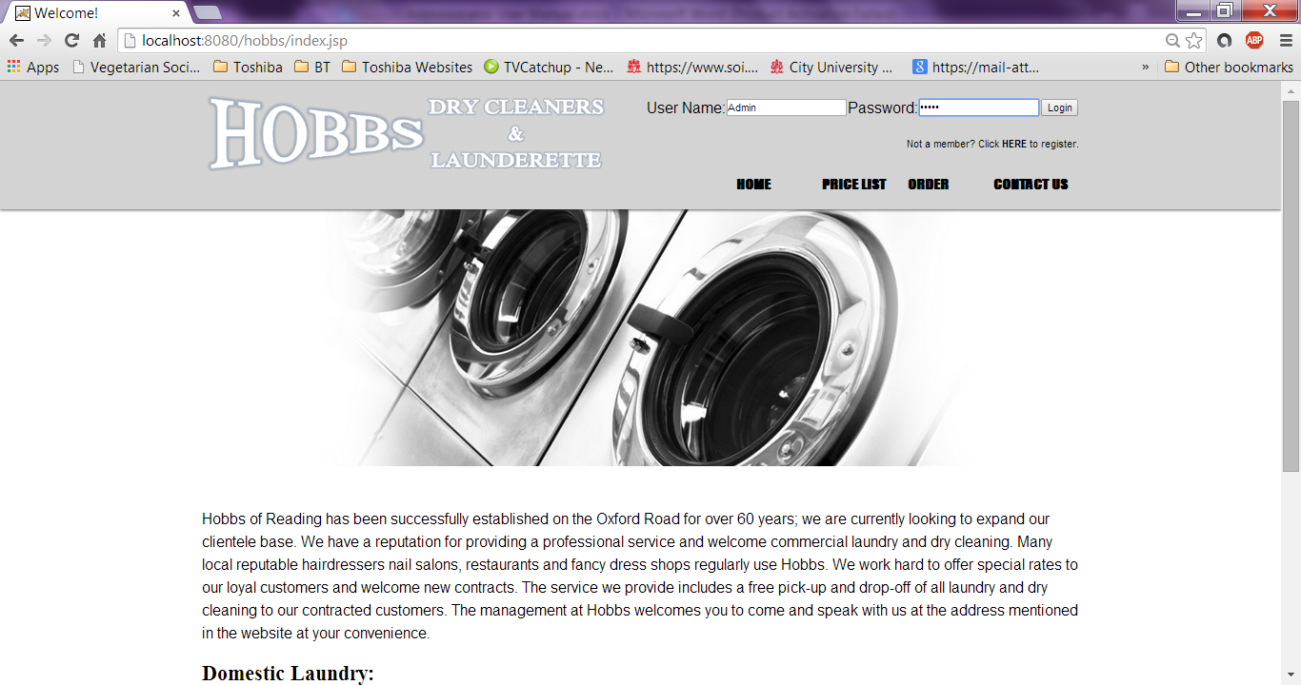
- After logging in, the user is displayed with the Admin Panel page. The user is also identified with the username they provided on the right top corner. “Logged in as Admin”
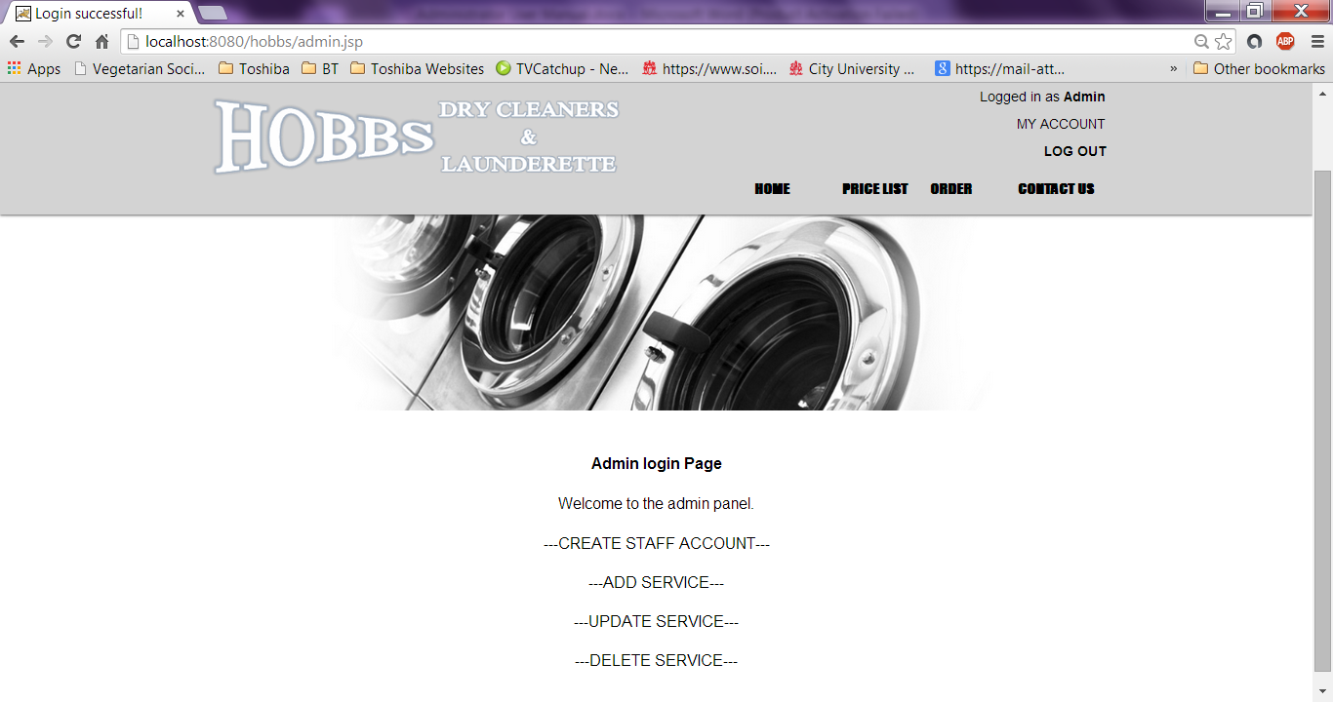
- If the user clicks on Create Staff Account. Then the user is enabled to create a new account for a new staff member within the business. A form is displayed allowing the Admin to register a new Staff member. The user can enter their first name, last name, email address, user name and password. Then click Submit, or Reset to start again.

Please note: The user can click on My Account to go back to Admin Panel
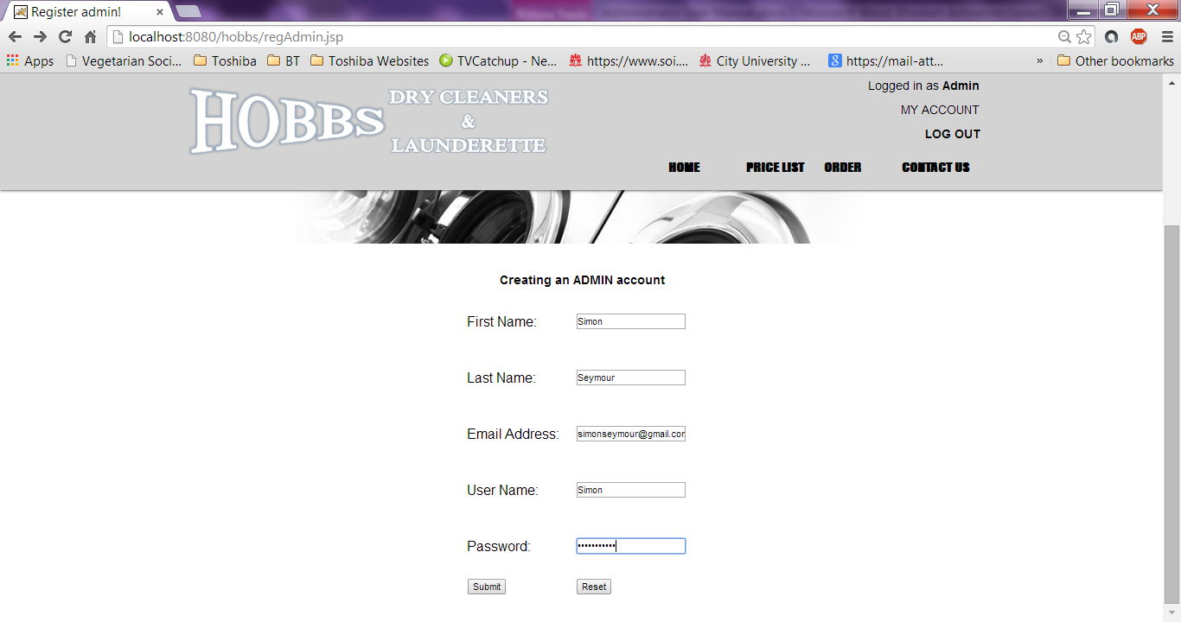

- After the Admin has registered a new staff member. The user is displayed with a confirmation page for creating a new staff account. The user can then click ‘here’ to allow the new staff member to log in with their username/ password to also view the Admin Panel.
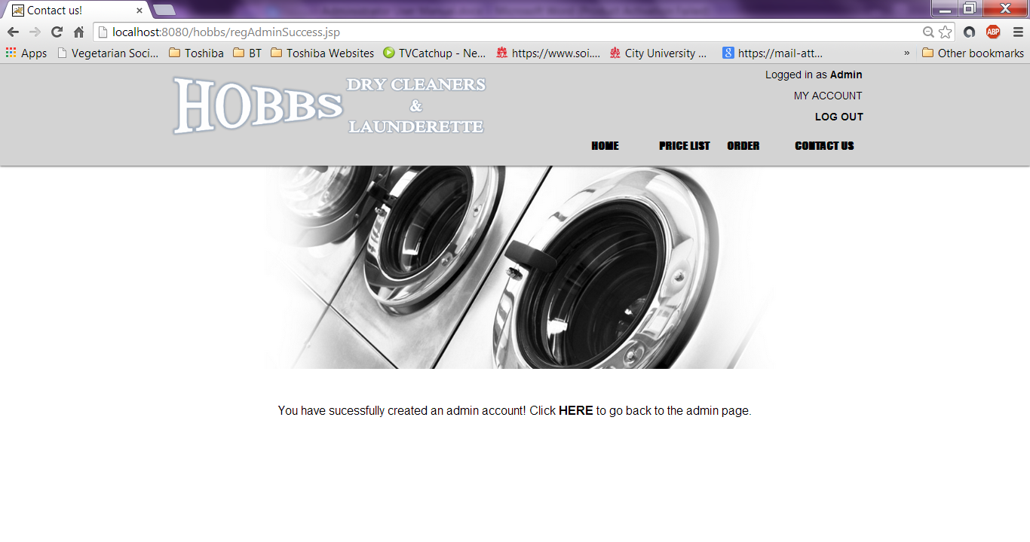
- If the user clicks on Add New Service from Admin Panel. Then the user is enabled to add a new service. These entries would be displayed on the Price List page where customers can view this new added information. A form is displayed allowing the Admin to add a service name, description and price manually. Then click Add or Reset to start again.
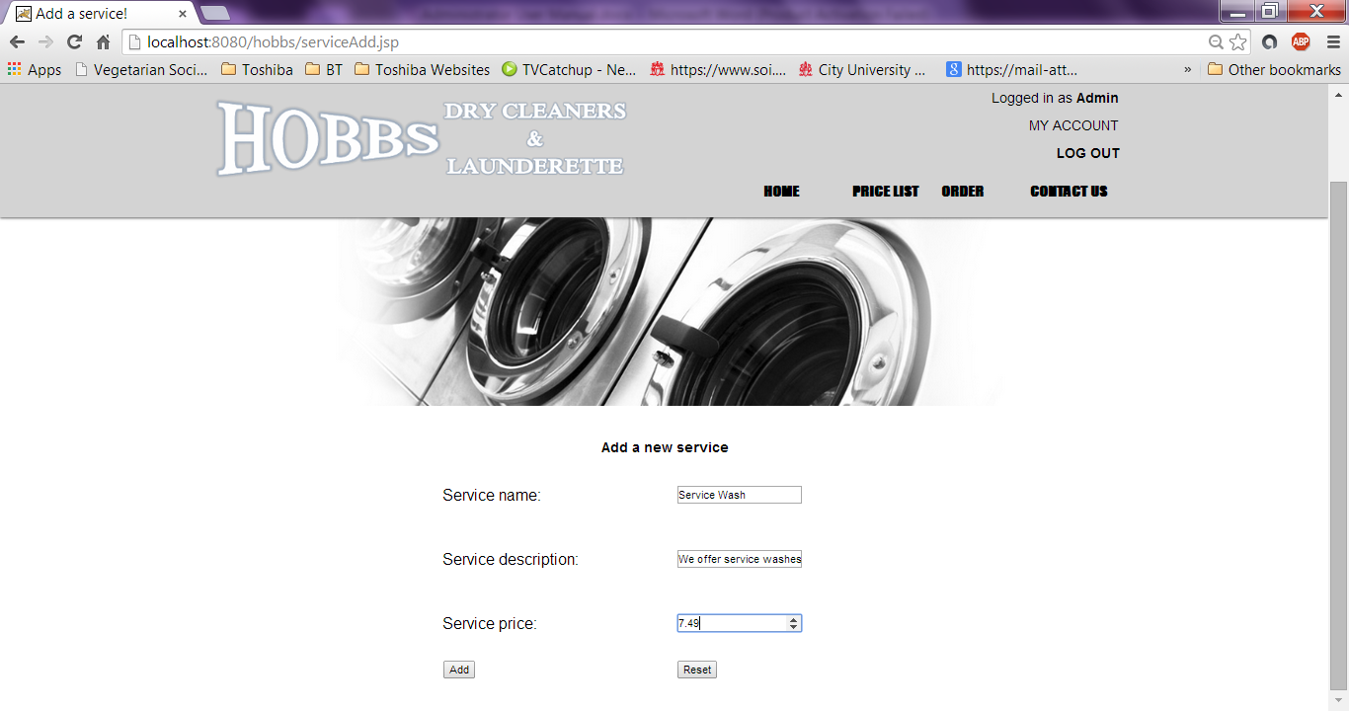

Please note: The user must fill in all boxes as well as enter the correct content in all boxes. (When entering a Service Price, the user must enter a number to continue with adding the service) Otherwise a warning would display notifying the user.
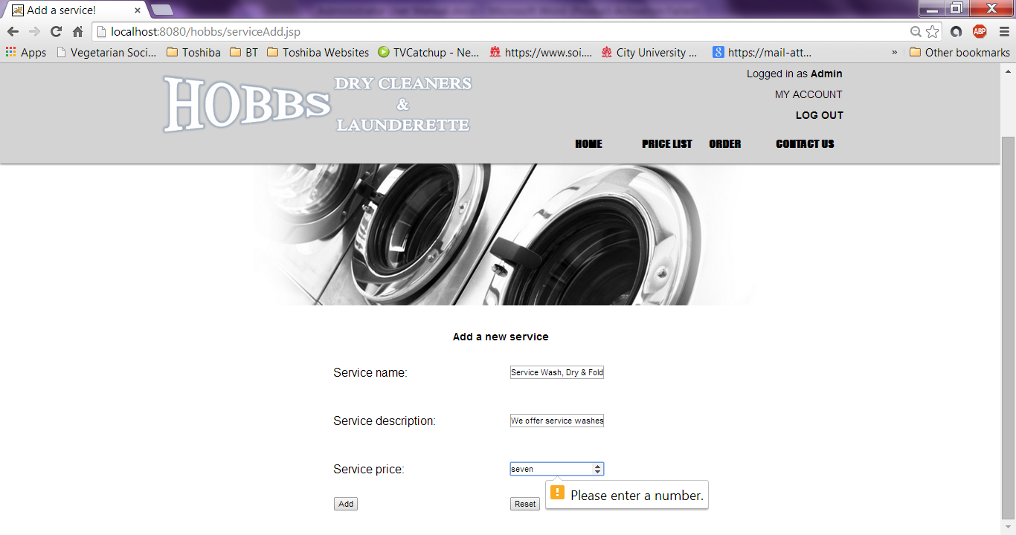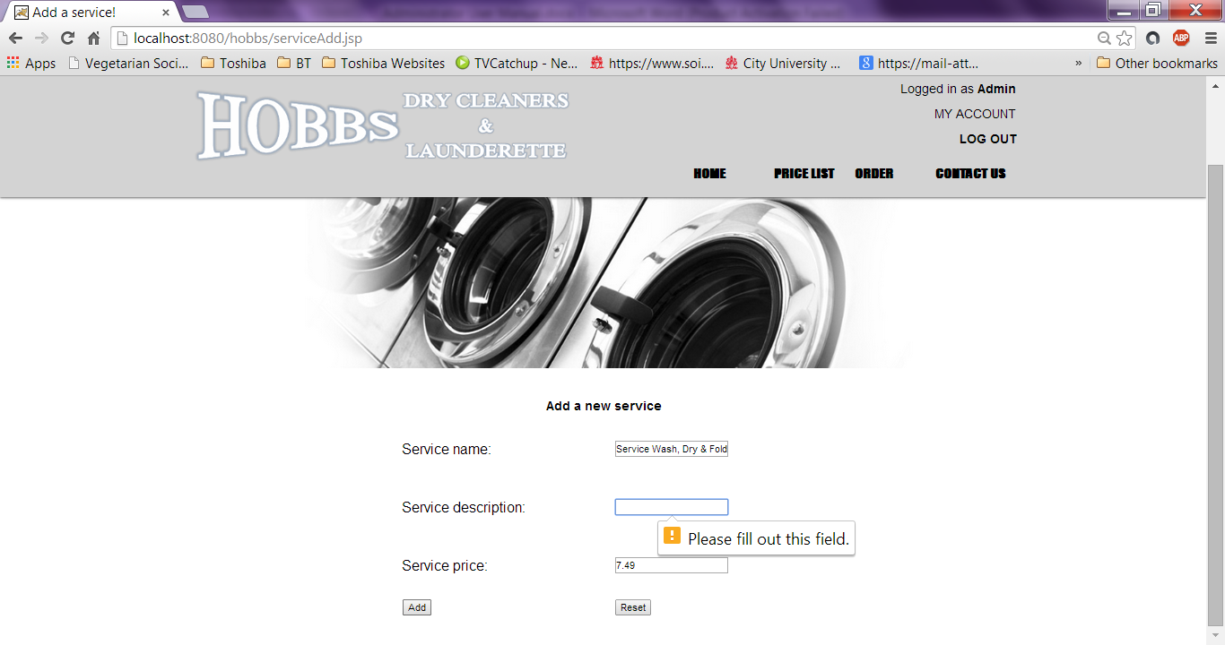
- After the user has added a new service successfully. The user is displayed with a confirmation page for adding a new service.

Please note: The user can click on Price List to view the new added service or click My Account to back to Admin Panel.

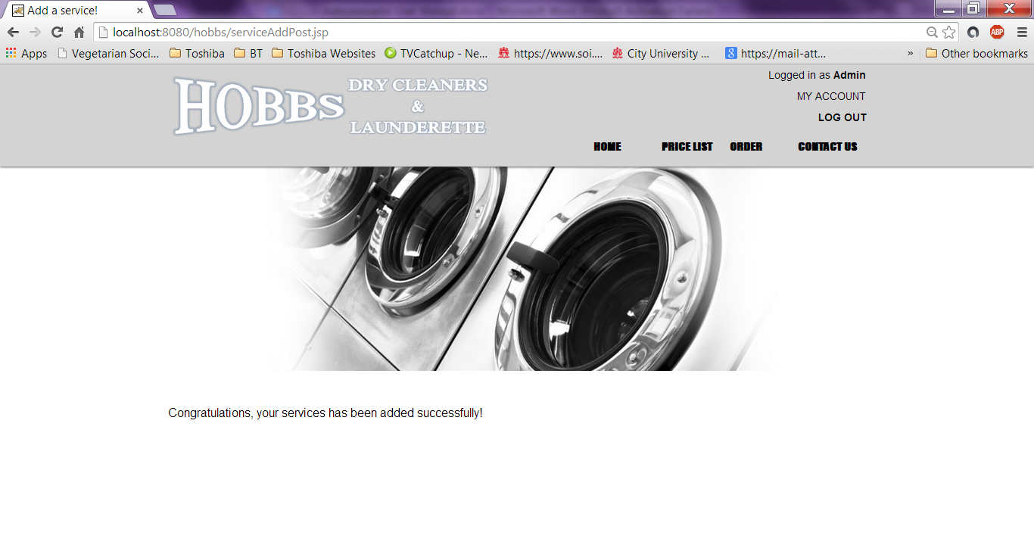

- If the user clicks on the Price List link from the navigation bar, this will visit a page which will display all the service item names, its description and price. The user can add, update and delete these service details manually. If the user wanted to make changes with updating the existing fields, they can do this by clicking Update Service on Admin Panel. This manual will show an example to change the first service Laundry to Service Wash details.
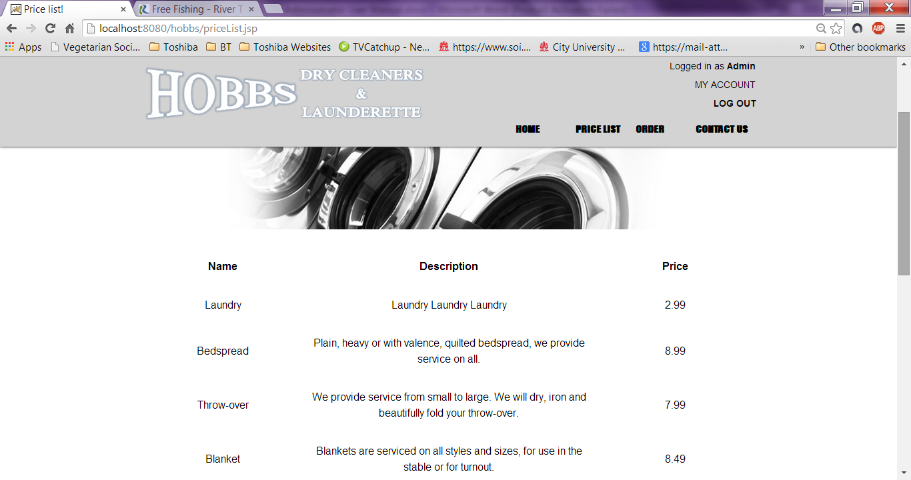

- If the user clicks on My Account to go back to Admin Panel. The user is enabled to update the current service displayed on Price List page. A form is displayed allowing the Admin to enter the service ID, update the service name, description and price. Then click Update or Reset to start again.

Please note: The service ID to make changes to a specific service can be found in the webpage displayed under the form next to the existing services.
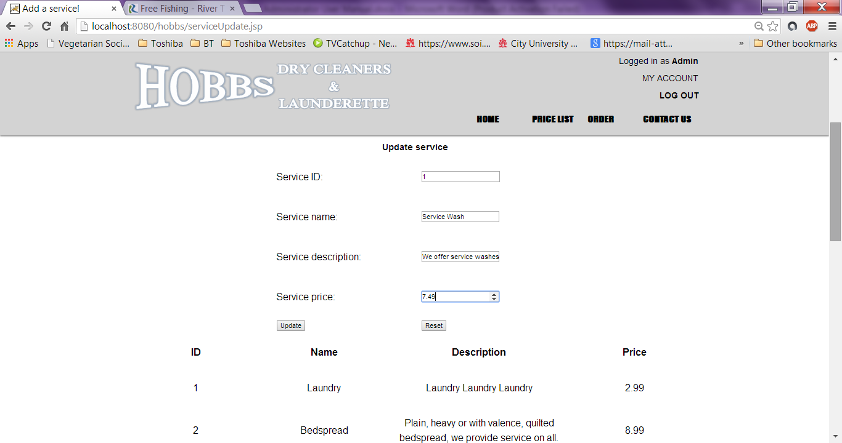
- After the user has added updated a service successfully. The user is displayed with a confirmation page for updating the service.

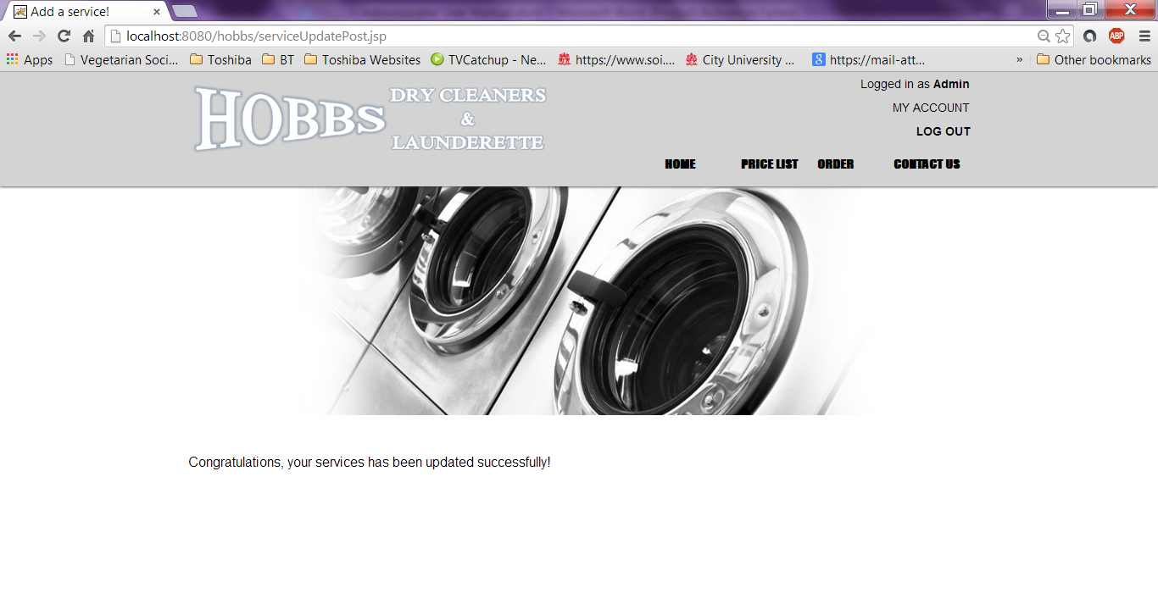
Please note: The user can click on Price List to view the updated service or click My Account to back to Admin Panel.
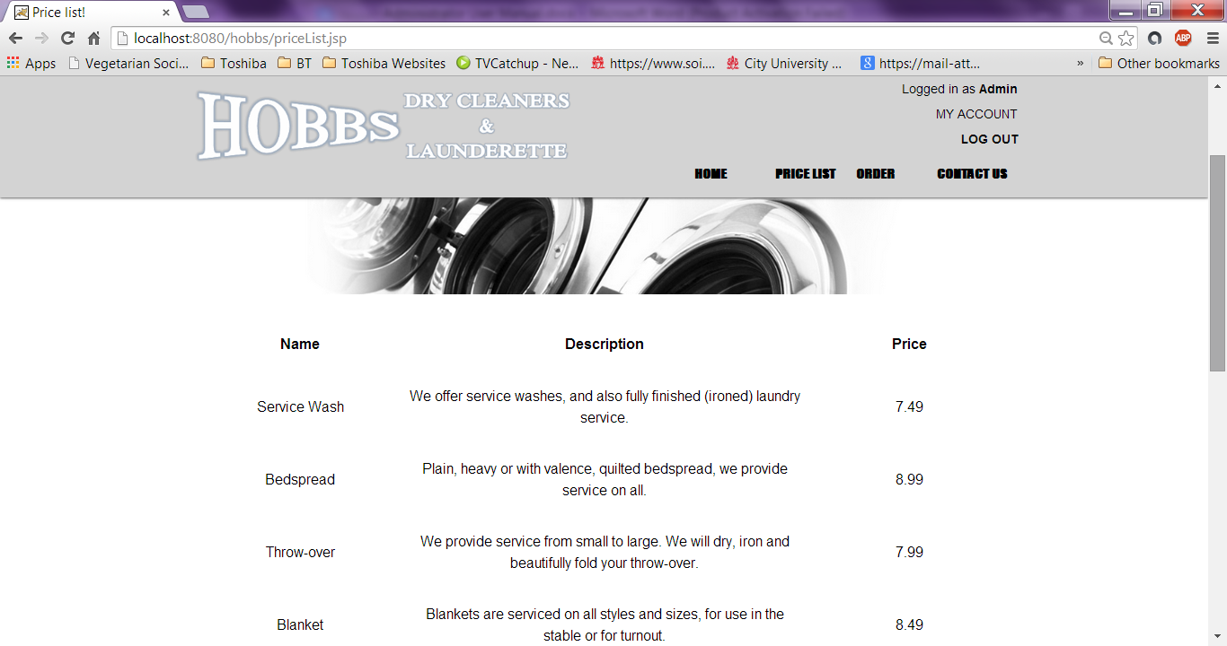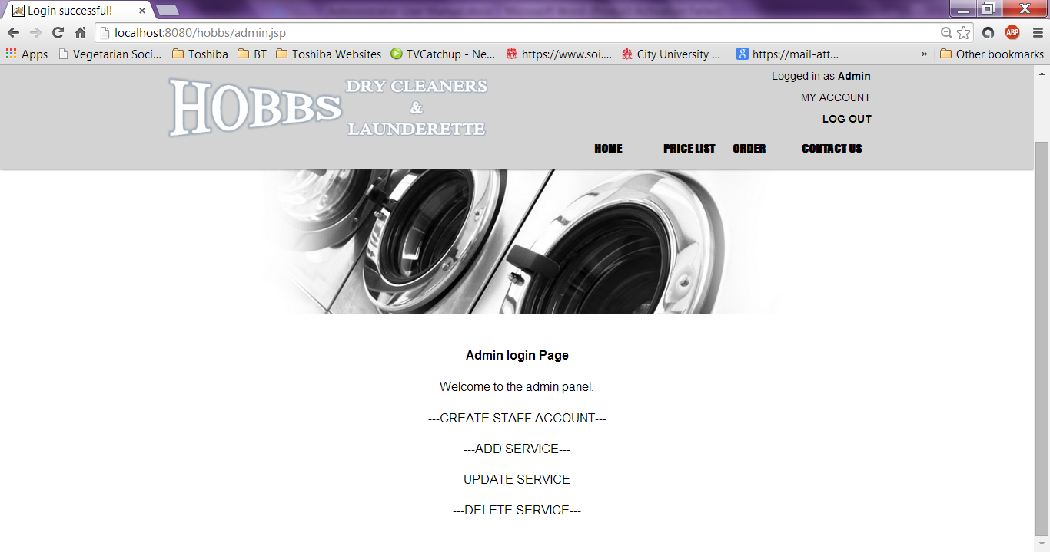

- If the user clicks on Remove Service from Admin Panel. Then the user is enabled to delete an existing service. This manual will show an example to delete the service details from Service ID: 2 (Bedspread). 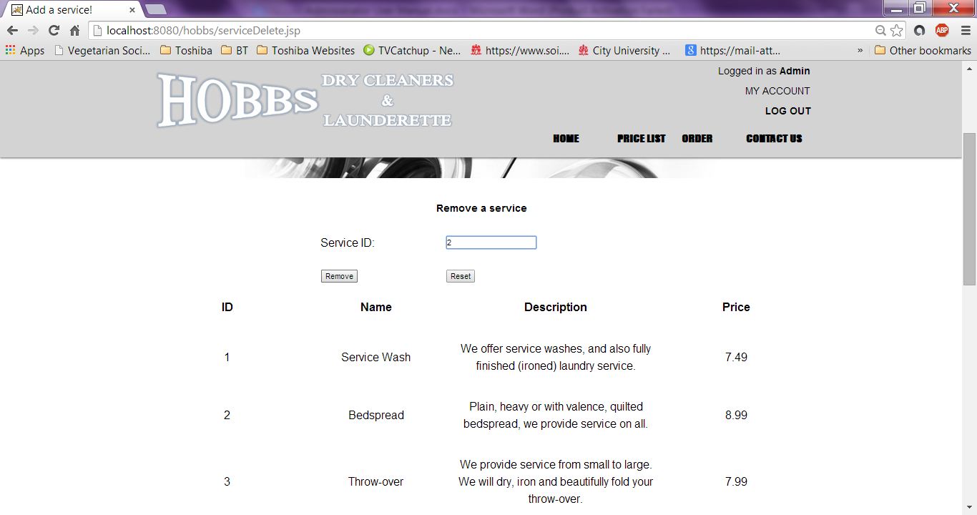
- The user will be confirmed that that the service item specified with the ID has been successfully deleted.
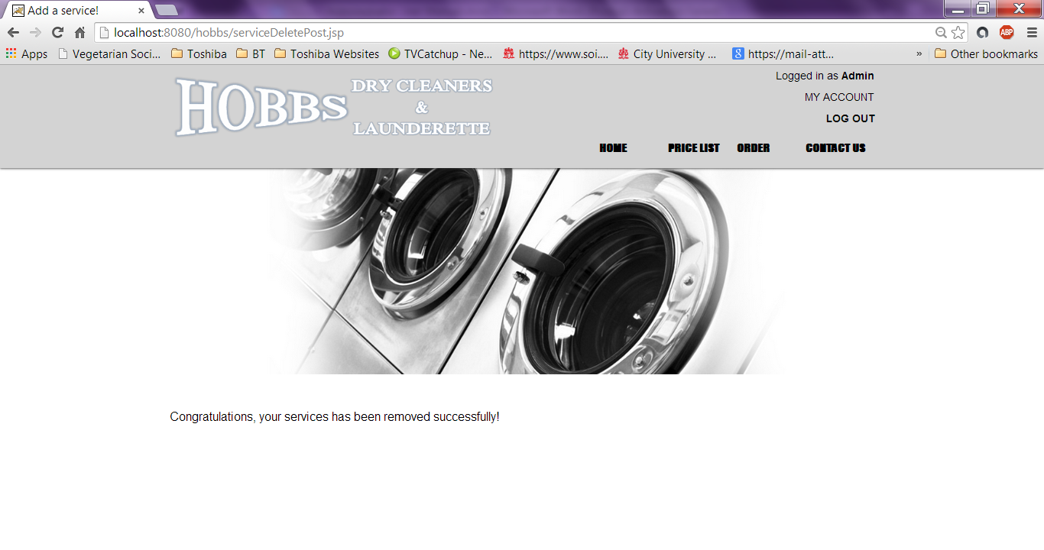

- After sucessfully deleting a serice. Ther user can go back to Remove Service through the Admin Panel to prove the specific service entered with its ID has been deleted.
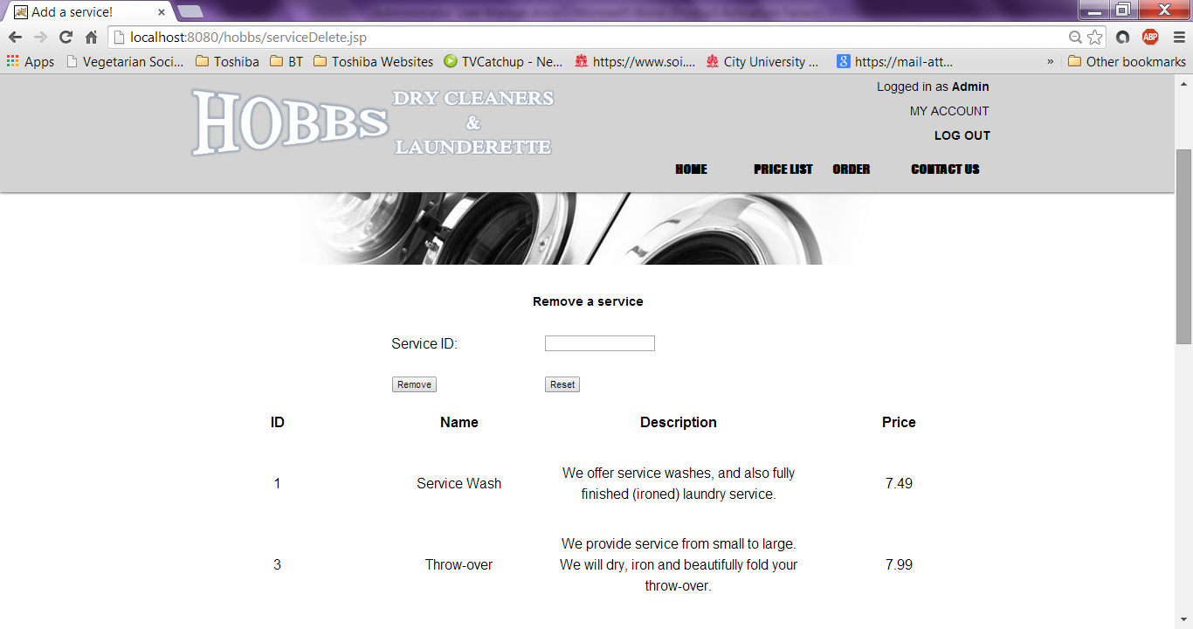
Please note: If the user visits the Price List page, the service (Bedspread) is not noticable anymore therefore it has been sucessfully deleted .
